Suicide Prevention and Crisis Services

Year Founded:
Website: www.suicidepreventionyolocounty.org

Financial information
2021 Revenues: $494,760
2021 Expenses: $306,140
Assets: $569, 107

11,018 callers Served in 2021

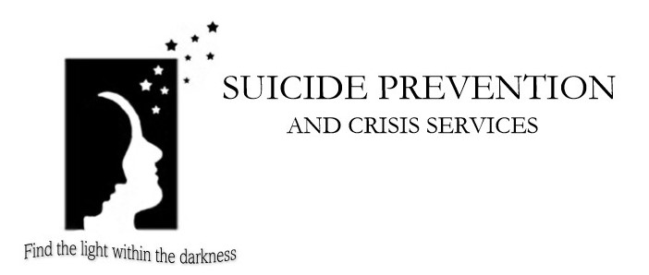

The mission of Suicide Prevention and Crisis Services of Yolo County is to provide crisis prevention and intervention, education and community outreach services to the residents of Yolo County.

Programs
SOS-Signs of Suicide School Program - SOS Signs of Suicide® programs are depression awareness and suicide prevention programs that can be implemented in one class period. We provide both the middle school and high school program, which can also be used in alternative settings serving youth such as: social clubs, after school programs, and juvenile justice systems.

24-Hour Crisis Lines - Confidential telephone counseling and referral information is provided any time of day or night by trained crisis volunteers. Immediate crisis intervention over the phone can decrease the need for more intensive counseling services.

ASK Teen Crisis Lines
The Allied Services for Kids (ASK) teen line began in December 1994 to provide 24-hour availability to teens and families in crisis. Whatever the problem, teens are welcome to call this confidential crisis line for support.

School Safety Tip Lines -
This 24-hour confidential tip line is where students in Davis and Woodland can report concerns about school safety, including information about possible violence or incidents of harassment. Since the school shooting tragedy at Columbine, such student reports have saved hundreds of lives.

Friends & Families of Suicide Loss Support Group - This once-a-month group provides a place for people who have lost someone to suicide. With the aid of a professional facilitator, group members help each other through the painful grief associated with a suicidal death. It is free and open to anyone.

