[Rural Innovations in social economics, inc]

Year Founded: 1987
Website: www.riseinc.org

Financial information
[2021/22 Fiscal Year] Revenues: 2.2 Million
[2021/22 Fiscal Year] Expenses:1.6 Million
Assets:

3,500 Community Members Served [in previous year]

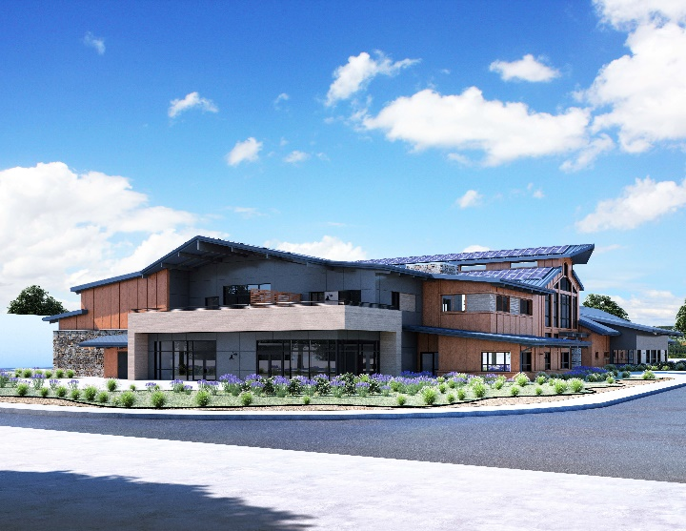

[RISE, Incorporated is a public benefit non profit organization that serves the rural communities to enhance the quality of life and opportunity for self sufficiency]

Programs

[RISE [Rural Innovations in Social Economics] Inc. organized as a public benefit non-profit [501.c.3] corporation in March 1987. Since its inception, RISE Inc. has been endorsed by the community as the social service delivery entity in rural western Yolo County. The organization’s specialty is rural program design and delivery; its strength is engaging the community in active self-determination and motivated self-sufficiency. The Winters and Esparto-Capay Valley Region encourages all human and social services to be clustered under the RISE Community Service Center umbrella. This incubation of services and programs has increased efficiency and is cost-effective.
RISE has a strong record of financial stability, budget management, and administrative capability. RISE has a local Board of Directors, employs program-specific staff, completes annual audits, and has numerous contractual and grant-funded programs to benefit local residents and community development ventures in the Winters and Esparto-Capay Valley Region of Western Yolo County.
Since incorporating 35 years ago RISE has provided a wide range of social services to our communities. RISE Incorporated provides and delivers seamless services to the entire population of western rural Yolo County. We provide services from pre-school experiences through senior citizen recreation and resource programs. RISE provides after school programs funded through the California Department of Education (CDE), Workforce Innovation Programs for youth (WIOA), emergency food, clothing, and a variety of resource and referral services to all community members. RISE is truly the “one stop shop” for social services in western rural Yolo County and a strong resiliency catalyst for young people in the community.

