PRIDE Industries

Year Founded: 1966
Website: www.prideindustries.org

Financial information
FY 2020
Revenues: $335,440,428
Expenses: $324,396,128
Assets: $110,443,000

# Served 2020

Services | #
Job/occupational skills training | 1038
Basic adult education programming (e.g., GED, ESL, computer literacy, reading/math) | 430
Work readiness training (communication, resume writing, interview skills) | 1260

PRIDE serves customers in 15 states plus Washington, D.C., and provides employment to 5,600 people, nearly 60 percent of whom have a disability.

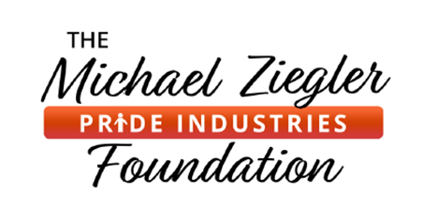

Our mission is to create employment for people with disabilities.
PRIDE Industries is a pioneer in social enterprise. For 55 years, we’ve provided competitive business services to fuel our mission of creating sustainable employment for people with disabilities. Since 1966, companies and government institutions have put their trust in PRIDE Industries’ competitive business services and inclusive workforce.

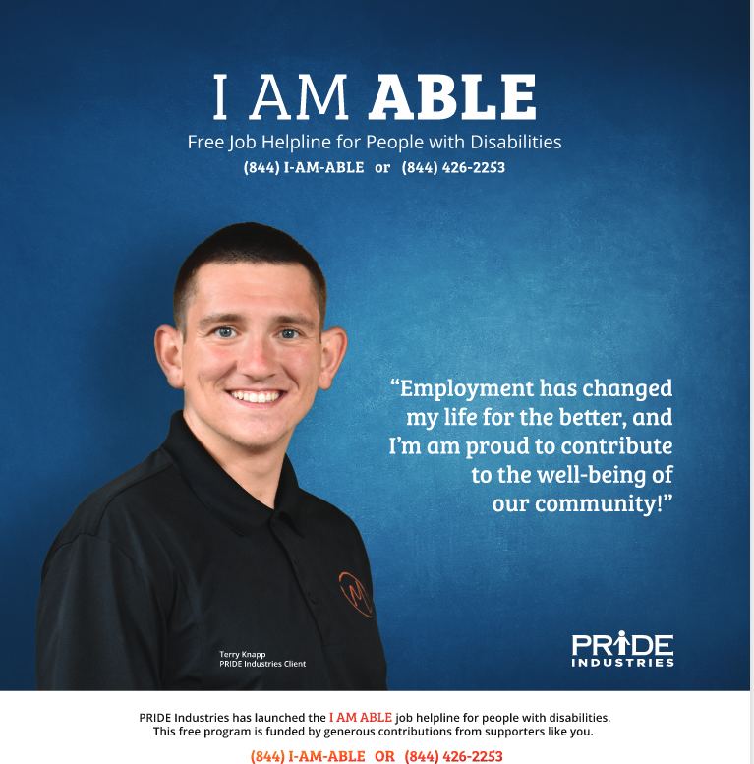
Programs
One in five Americans has a disability, and two-thirds of working-age Americans with disabilities are unemployed. At PRIDE Industries, we know that a job means so much more than a paycheck; it also has the power to bring connection, community, and purpose.
With your support, we can expand employment opportunities for a significant number of Americans. When you donate to The Michael Ziegler PRIDE Industries Foundation, you directly help people with disabilities experience the dignity of a paycheck and the pride that comes with meaningful work. And it’s not just individuals who are helped. When more people
are able to work, the entire community benefits socially and economically.
We work with individuals throughout their employment journey to provide career access, choice, and advancement opportunities. When you donate to our Foundation, you support a broad range of personalized services for people with disabilities. And because PRIDE Industries funds all of our Foundation’s administrative costs, 100% of your donation goes directly to support these life-changing programs:
- Vocational Training- essential training and job certifications—giving people with disabilities and barriers to employment an opportunity to succeed in a competitive job market
- Job Coaching - Our Job Coaches provide a safe, well-supervised training environment using a person-centered approach that ensures lasting success for both employer and employee.
- Internships - internships give people with disabilities and other barriers to employment the opportunity to learn new skills and demonstrate their abilities to potential employers.
- Assistive Technology - We furnish critical aids—such as software, hearing aids, and motorized scooters—that enable people with disabilities to succeed in the workplace.
- Transportation- our fleet of buses transport people who are unable to drive to work or medical appointments, and enable us to deliver essentials such as groceries and medicine.
- I AM ABLE Helpline - Our I AM ABLE Helpline connects people who face barriers to employment, as well as their family members, to essential career and support services.

